Docker Task -02
- Create a tomcat container on 8080 and deploy sample application in tomcat.

Step 1: Pull the Tomcat image
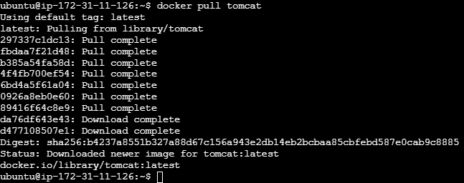
Step 2: Create and run the Tomcat container
Step 3: Check the running container

Step 4: Create a WAR file

Install Maven on the server to create a package: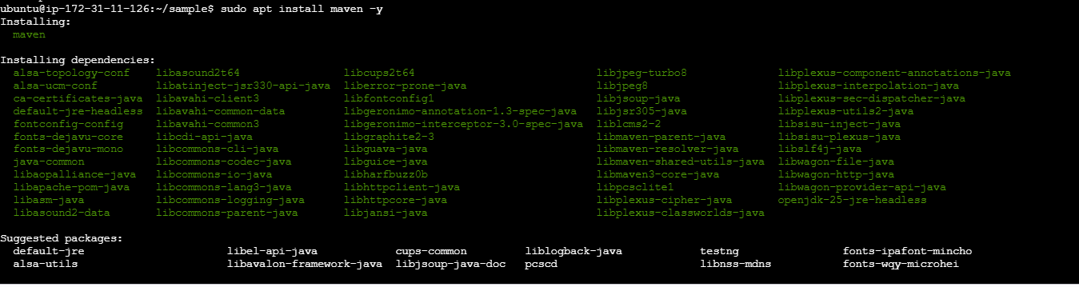

Step 5: Create a basic java web application using Maven 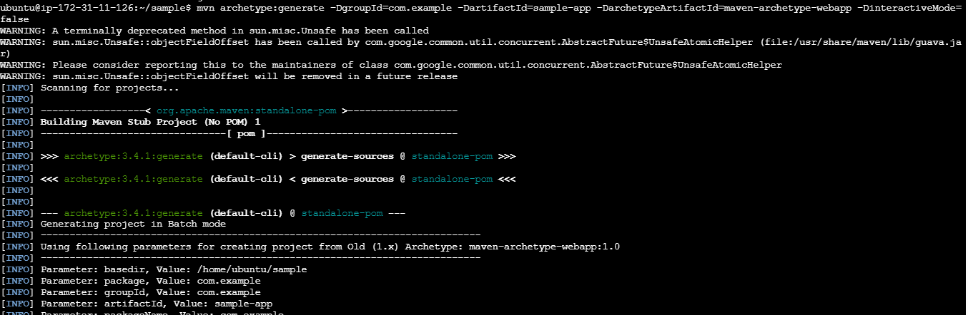

Step 6: Now go into sample-app and build a .war file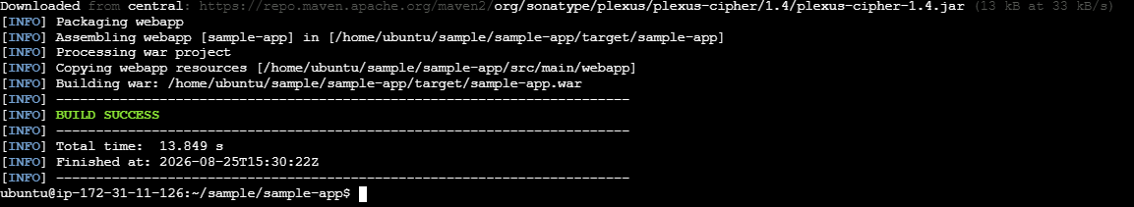

Copy sample-app.war into Tomcat and verify it

Then access it on browser:

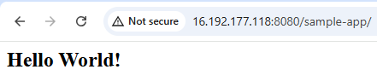
2. Create volume and deploy tomcat container on port 8081.

Step 1: Create a Docker volume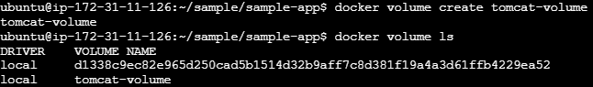

Step 2: Create and run Tomcat on port 8081 and verify it

Step 3: Test Tomcat

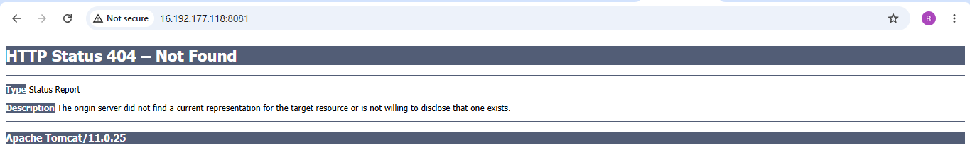
3. Limit the nginx container to 500 MB.
Step 1: Pull the Nginx image
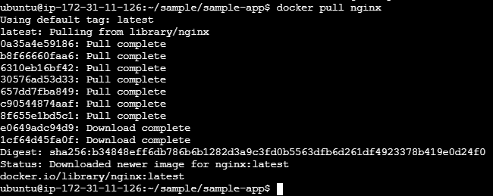
Step 2: Run Nginx with a 500 MB memory limit on port 8082 and verify the containe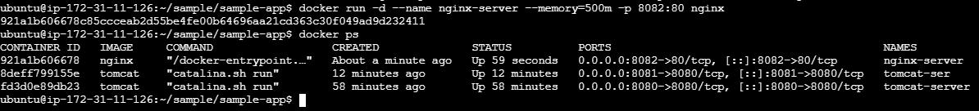
Step 3: Check the memory limit
4. Create a sample docker file using below instructions.
- Base module as amazonlinux:latest
- Maintainer you name
- Install nginx
- COPY one index.html file to image
- Expose on port 80
- Command to start the nginx container

Step 1: Create a directory, enter directory and create index.html with vi
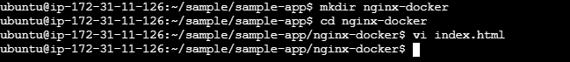

Step 2: Create the Dockerfile
Using vi create a dockerfile and the script into the file
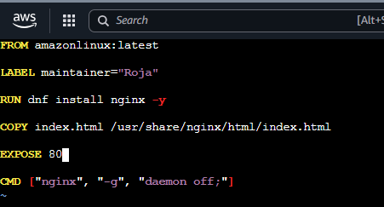

Step 3: Build the Docker image
Run this from the directory containing Dockerfile and index.html:
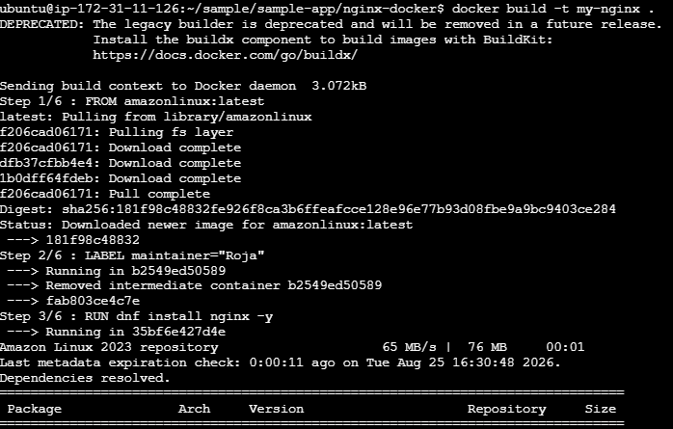
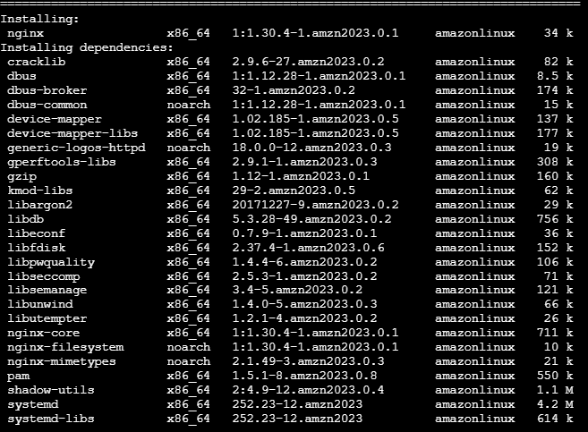
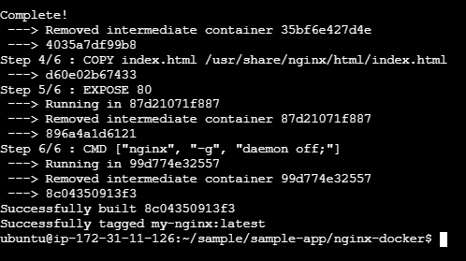

Step 4: Check the image
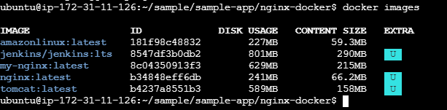

Step 5: Create and start the container and check the container

Step 6: Test Nginx

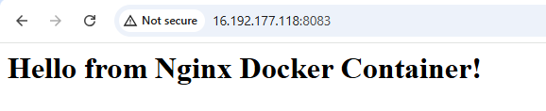
5. Push image to Docker hub

Step 1: Create a Docker Hub account
Go docker-hub website and create a free account.
Choose a Docker ID/username. For example:

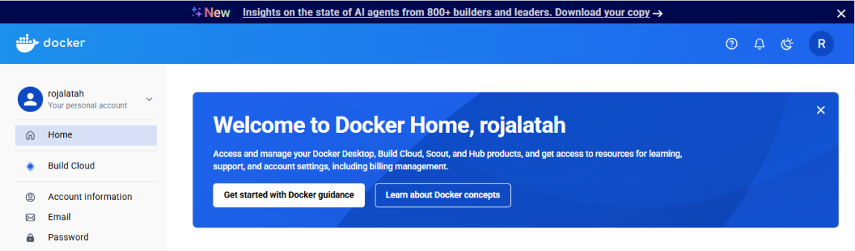

Step 2: Create an Access Token
After logging in to Docker Hub:
Profile → Account Settings → Personal access tokens → Generate new token
Give the token permission to Read & Write.

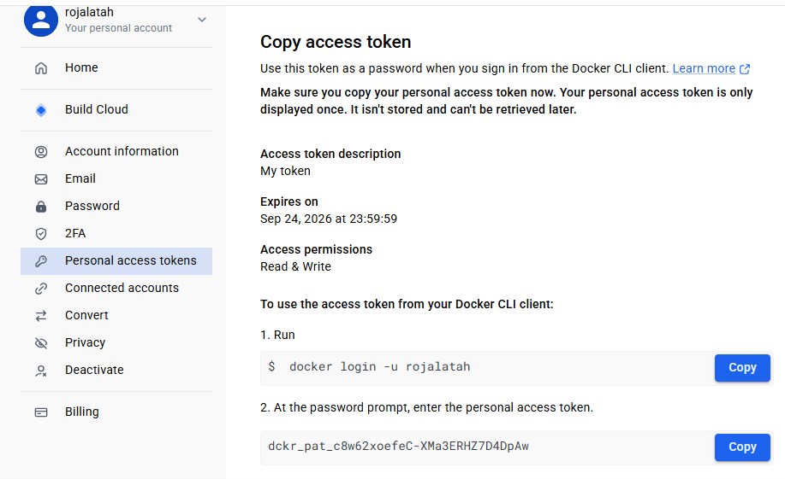

Step 3: Login from Ubuntu
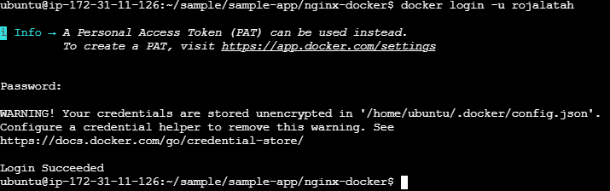

Step 4: Tag your image and push the image to docker-hub

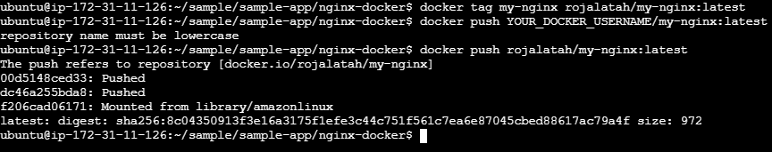

Step 5: Verify docker image in local
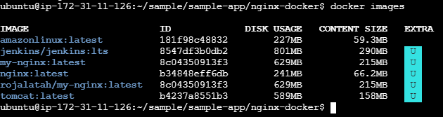
Step 6: Verify image on Docker-hub
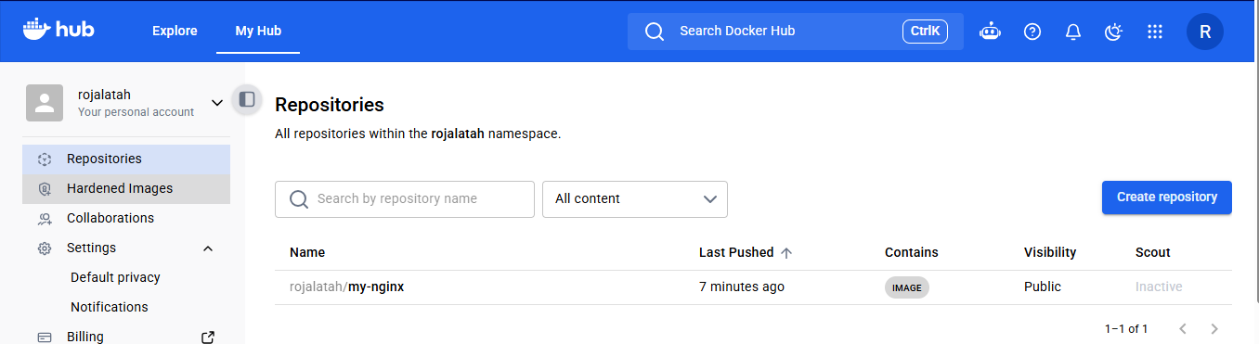

6. Push image to AWS ECR
Step 1: Configure AWS CLI
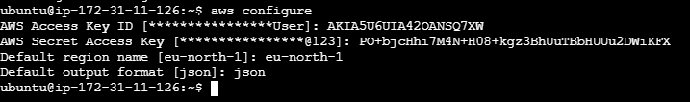

Step 2: Create an ECR repository
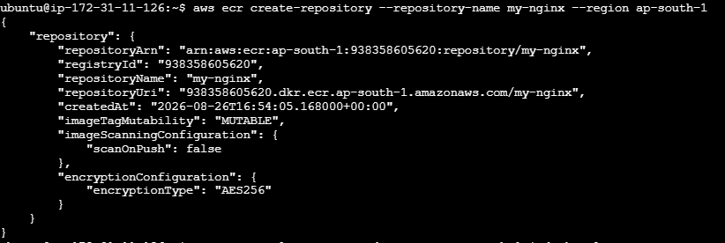

Step 3: Login to ECR

Step 4: Tag your Docker image and verify the images

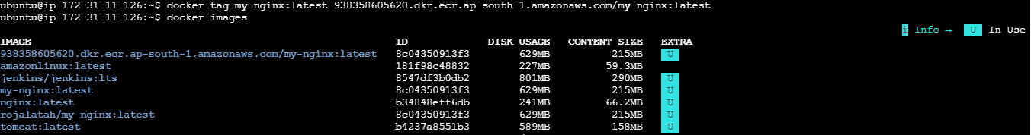

Step 5: Push the image and Verify the image in ECR
Docker will upload the image layers to your ECR repository

